Biology 252/254 Exam 1, Fall 2005 Rick Kesseli

Your Name
Answer all questions. Show your work clearly. You may be eligible for partial credit even if your answer is wrong. It is probably better NOT to erase as sometimes there is work worth some credit in that scribbling.

1. (24 point Donut Question). The number of chromosomes in a cell of the wing of the recently discovered Ivory-billed Woodpecker is 8. i) Using chromosomes with different morphologies (different positions of the centromere and/or different lengths), draw the chromosomes in this adult female as they would appear in a) metaphase of mitosis, b) anaphase I of meiosis; c) anaphase II of meiosis and d) G1 stage (pretend you can see them in G1) of the cell cycle.
ii) Your adult female is heterozygous for two independent genes, the goofy locus Gg and the happy locus Hh. Label ALL locations of your genes in your four (a,b,c,d) figures. There is no crossing over in this species.
iii) Assuming that there are 5 picograms of DNA in the cell of your “figure d” above, how much DNA would be found in the cells in figure a, b and c above? How much would be in the sperm of this bird?

2. (8 points). Give an example and explain how the environment might affect the dominance relationships of alleles of a single gene trait.

3. (8 points). If you discover two mutants for flower color in plants, how can you determine if they involve the same gene or different genes?

4. (12 points). In bunny rabbits, the following genotypes of two independent genes determine coat color.
A_B_ gray; A_bb = cream, aaB_ = black; aabb = yellow.
A third gene (C) creating albinos determines whether the color is deposited in the coat. The mutant gene prevents deposition and is recessive.
Show the genotypes of the offspring below and predict the genotype and phenotype of the parents who produced them.
a) 3/8 black: 3/8 gray: 2/8 albino

b) 1/8 gray; 1/8 black: 1/8 cream: 1/8 yellow: 4/8 albino

5. (12 points). With reference to the eye color phenotypes produced by the recessive autosomal unlinked brown and scarlet loci in Drosophila, predict (show phenotypes and genotypes) the F1 and F2 results of the following cross of inbred P1parents. Recall that white occurs when no pigment is produced and brick-red occurs when all pigments are produced.

Scarlet x Brown

6. (20 points). In roses, inbred varieties may be red, yellow, white and dark purple. If one of these lines with red flowers is crossed to one with yellow flowers, all the progeny are dark purple. You intercross two of these F1s and get the following progeny: 176 purple, 63 red, 59 yellow and 22 white.
a) Describe the inheritance of flower color by defining gene symbols and phenotypes. Define the genotypes of the parents, F1 and F2 progeny produced in your cross. Test your genetic model with χ². And be sure to interpret the results of the test.

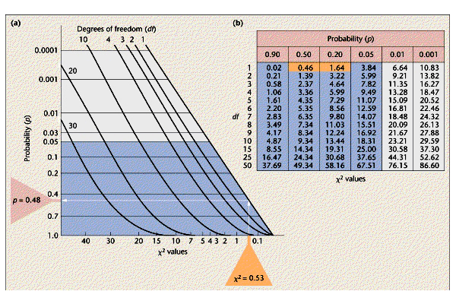

7. (12 points). For the human pedigree below, identify modes of inheritance (single gene dominant, single gene recessive) that can be excluded (if any) and give an explanation for the most likely mode. Clearly identify individuals in the pedigree that support your arguments.

8. (12 points). Tay Sachs is a recessive lethal in humans. Two normal parents have a Tay Sachs girl. A) What is the probability that their next child will be Tay Sachs? B) What is the probability that their next child will be a normal girl? C) What is the probability that their next two children will be normal and the same sex?

Bonus (5 points). If the parents have five children, what is the probability that four will be normal and one has Tay Sachs?

